**Taylor Series Visualizer**

Akilesh S 23PD33

Jeyanth 23PD16

Input:

* The user is prompted to input the following parameters:
* A function `f(x)` to be approximated.
* An expansion point `a` around which the Taylor series is computed.
* The number of terms `n` for the Taylor series approximation.

syms x;

f = input('Enter a function (in terms of x): ')

a = input('Enter the expansion point (a): ')

n = input('Enter the number of terms (n): ')

Input:

Enter a function (in terms of x): 1/x^2

Enter the expansion point (a): 4

Enter the number of terms (n): 15

Taylor Series Calculation:

* The script then initializes the variable `taylor_series` to 0.
* It enters a loop from 0 to `n` that computes the `kth` derivative of the function at point `a`.
* Using the derivative, it calculates the `kth` term of the Taylor series expansion.
* The calculated term is added to the `taylor_series` variable.

for k = 0:n

kth_derivative = subs(diff(f, x, k), x, a)

term = (kth_derivative/factorial(k)) * (x - a)^k

taylor_series = taylor_series + term

end

Display and Plotting:

* The script displays the original function `f` and the computed Taylor series.
* It creates a plot to visualize the original function and the Taylor series approximation.
* The `linspace` function generates a range of `x_values` for plotting.
* The `subs` function calculates the corresponding `y` values for the original function and the Taylor series.
* It plots the original function in blue and the Taylor series approximation in red with a dashed line.
* Labels and a legend are added to the plot.

disp('Original Function:')

disp(f)

disp('Taylor Series:')

disp(taylor_series)

x_values = linspace(a - 2, a + 2, 400)

y_values_f = subs(f, x, x_values)

y_values_taylor = subs(taylor_series, x, x_values)

plot(x_values, y_values_f, 'b', 'LineWidth', 2, 'DisplayName', 'Original Function')

hold on

plot(x_values, y_values_taylor, 'r--', 'LineWidth', 2, 'DisplayName', 'Taylor Series')

xlabel('x')

ylabel('y')

title('Function and Taylor Series Approximation')

legend

Output:

* The script displays the original function and the Taylor series.
* It plots the original function and the Taylor series approximation on the same graph.

Original Function:

1/x^2

Taylor Series:

(3*(x - 4)^2)/256 - x/32 - (x - 4)^3/256 + (5*(x - 4)^4)/4096 - (3*(x - 4)^5)/8192 + (7*(x - 4)^6)/65536 - (x - 4)^7/32768 + (9*(x - 4)^8)/1048576 - (5*(x - 4)^9)/2097152 + (11*(x - 4)^10)/16777216 - (3*(x - 4)^11)/16777216 + (13*(x - 4)^12)/268435456 - (7*(x - 4)^13)/536870912 + (15*(x - 4)^14)/4294967296 - (x - 4)^15/1073741824 + 3/16

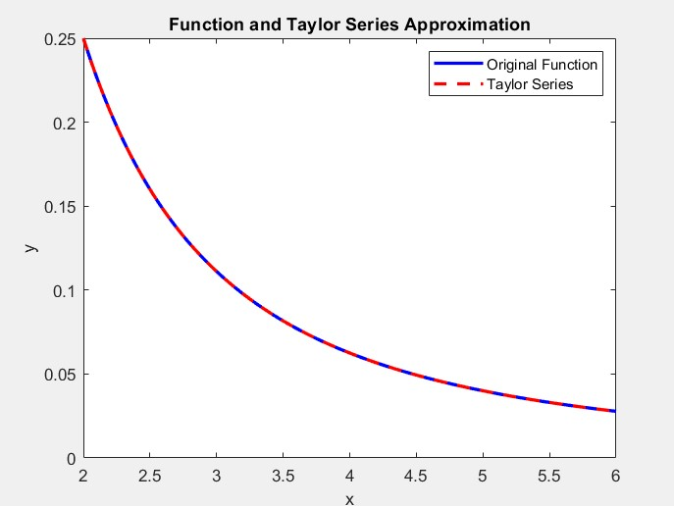

Usage of the Matlab:

* Make sure to have the MATLAB to use symbolic variables and functions.
* This script can be used to generate and visualize the Taylor series approximation for a given function.